Staff File Checklist

Staff Name:__________________________________________ Position: _________________________

Pre-Employment Forms
Staff Information Form
Past Employment References (one for each employer in past 2 years)
Past Employment Reference
W-4 (Employee) / W-9 (Contract)
Employment Eligibility Verification (I-9)
Affidavit of Good Moral Character (must be notorized)
Local Law Enforcement Check (Seminole and Orange Counties)
Job Description (Employee) or Contract (Contract)
Bachelor’s Level Practitioner Verification (N/A if Master’s level)
Confidentiality/HIPAA Agreement
Child Abuse & Neglect Reporting Requirements

Pre-Employment Attachments
fingerprint card (or FDLE & Federal clearances from current employer)
CFARS certificate (online training: http://outcomes.fmhi.usf.edu)
FARS certificate (online training: http://outcomes.fmhi.usf.edu)
Résumé
copy of College Degree or Transcripts
copy of Licenses / Certifications
copy of Driver’s License
copy of Social Security Card
other relevant trainings

Post Employment
Program Orientation
Credentialing Applications
FDLE Clearance Letter (can be transferred from current employer)
Federal Clearance Letter (can be transferred from current employer)
FDLE Sexual Predator Website Verification
90-day Evaluation (Employee)
Annual Evaluations (Employee)
5-year Rescreening Fingerprint Card and Clearance Letter
Annual Trainings

Staff Information Form

☒New Hire Personal Info Update Professional Info Update Work Info Update
Personal Information
Name (First, Middle, Last): _________________________________________________________________

SSN:________-______-_____________ Birth Date:_____/______/______
Optional: Male Female Single Married White Black Hispanic Other _________

Address/City/State/Zip: ____________________________________________________________________
Home Phone: (________) _________-_____________ Cell Phone: (________) ________-_____________
Work Phone: (________) _________-_____________ email:_______________________________________
Emergency Contact Person:_______________________________________________________________
Emergency Contact Person Phone #: (________) __________-______________
Professional Information
Highest Degree: ________ Year awarded:_________ Major:___________________________________
Not licensed Licensed Provisional License#:__________________ Exp Date:__________
Not certified BCBA-1 BCBA-2 BCABA Cert#:____________________ Exp Date:__________
National Provider Identification (NPI) #:______________________________
CFARS Rater#:_______________________________ FARS Rater#:_________________________________
Specialty areas (requires 6 months supervised experience in specialty treatment area):
Behavior Analysis Developmental Disabilities Verbal Behavior (Autism)
Early Intervention (0-5) Psychological Testing  Substance Abuse
Sexual Trauma Sexual Perpetration Domestic Violence
❑ Eating Disorders Reactive Attachment Disorder Other:_____________________
Work Information (to be completed by Administration)
Start Date: ______________ ☒Contract FT Employee PT Employee Temp Other:________

Position: _________________________________ Supervisor: _______________________________

Pay Rate: ________________
I certify that the information on this form is true and complete. I understand that it is my responsibility to notify Collaborative Solutions of any changes in this information.

Staff Signature:__________________________________________________ Date:__________________
Manager Signature:_____________________________________________ Date:__________________
Past Employment Reference Check
*********************************TO BE COMPLETED BY APPLICANT**********************************

Applicant Name: __________________________________________________________________________

Reference Name:_____________________________________ Phone #____________________________
Agency: _____________________________________ Employment Period:_________________________
****************************TO BE COMPLETED BY PREVIOUS EMPLOYER*****************************
Eligible for rehire? Yes No If no, explain:_______________________________________________
____________________________________________________________________________________

Applicants reason for leaving: ______________________________________________________________
Applicants job duties: ______________________________________________________________________
Please rate and comment on the following performance characteristics:
 | Excellent | Good | Satisfactory | Fair | Poor | N/A
Professionalism
Clinical skills
Writing skills
Dependability/Follow through
Initiative
Ethics
Attendance/Punctuality
Relationship with peers
Relationship with superiors

Additional Comments:

Send completed reference to:
fax: (407) 542-4806
email: nixabcba@aol.com
mail: 3516 Wild Eagle Run Oviedo FL 32766
or call Dr. Keefer (407) 489-2121 to give reference via telephone

____________________________________________________
Reference Signature Date
Past Employment Reference Check
*********************************TO BE COMPLETED BY APPLICANT**********************************

Applicant Name: __________________________________________________________________________

Reference Name:_____________________________________ Phone #____________________________
Agency: _____________________________________ Employment Period:_________________________
****************************TO BE COMPLETED BY PREVIOUS EMPLOYER*****************************
Eligible for rehire? Yes No If no, explain:_______________________________________________
____________________________________________________________________________________

Applicants reason for leaving: ______________________________________________________________
Applicants job duties: ______________________________________________________________________
Please rate and comment on the following performance characteristics:
 | Excellent | Good | Satisfactory | Fair | Poor | N/A
Professionalism
Clinical skills
Writing skills
Dependability/Follow through
Initiative
Ethics
Attendance/Punctuality
Relationship with peers
Relationship with superiors

Additional Comments:
Send completed reference to:
fax: (407) 542-4806
email: nixabcba@aol.com
mail: 3516 Wild Eagle Run Oviedo FL 32766
or call Dr. Keefer (407) 489-2121 to give reference via telephone

____________________________________________________
Reference Signature Date
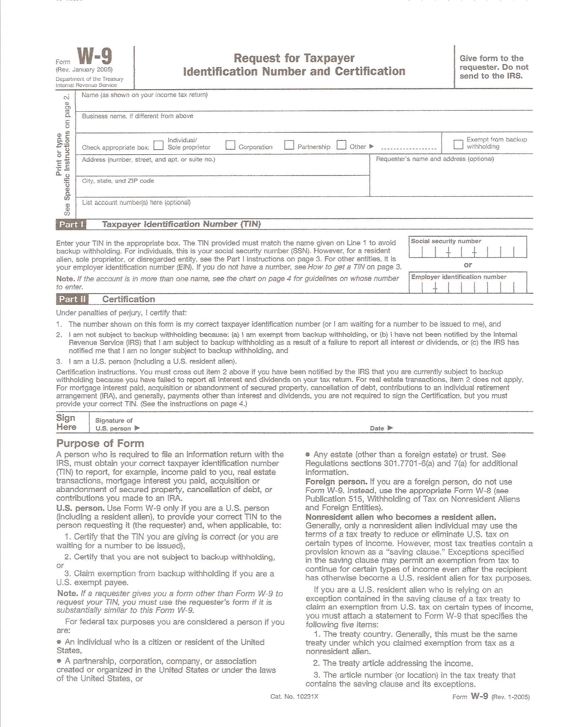

x

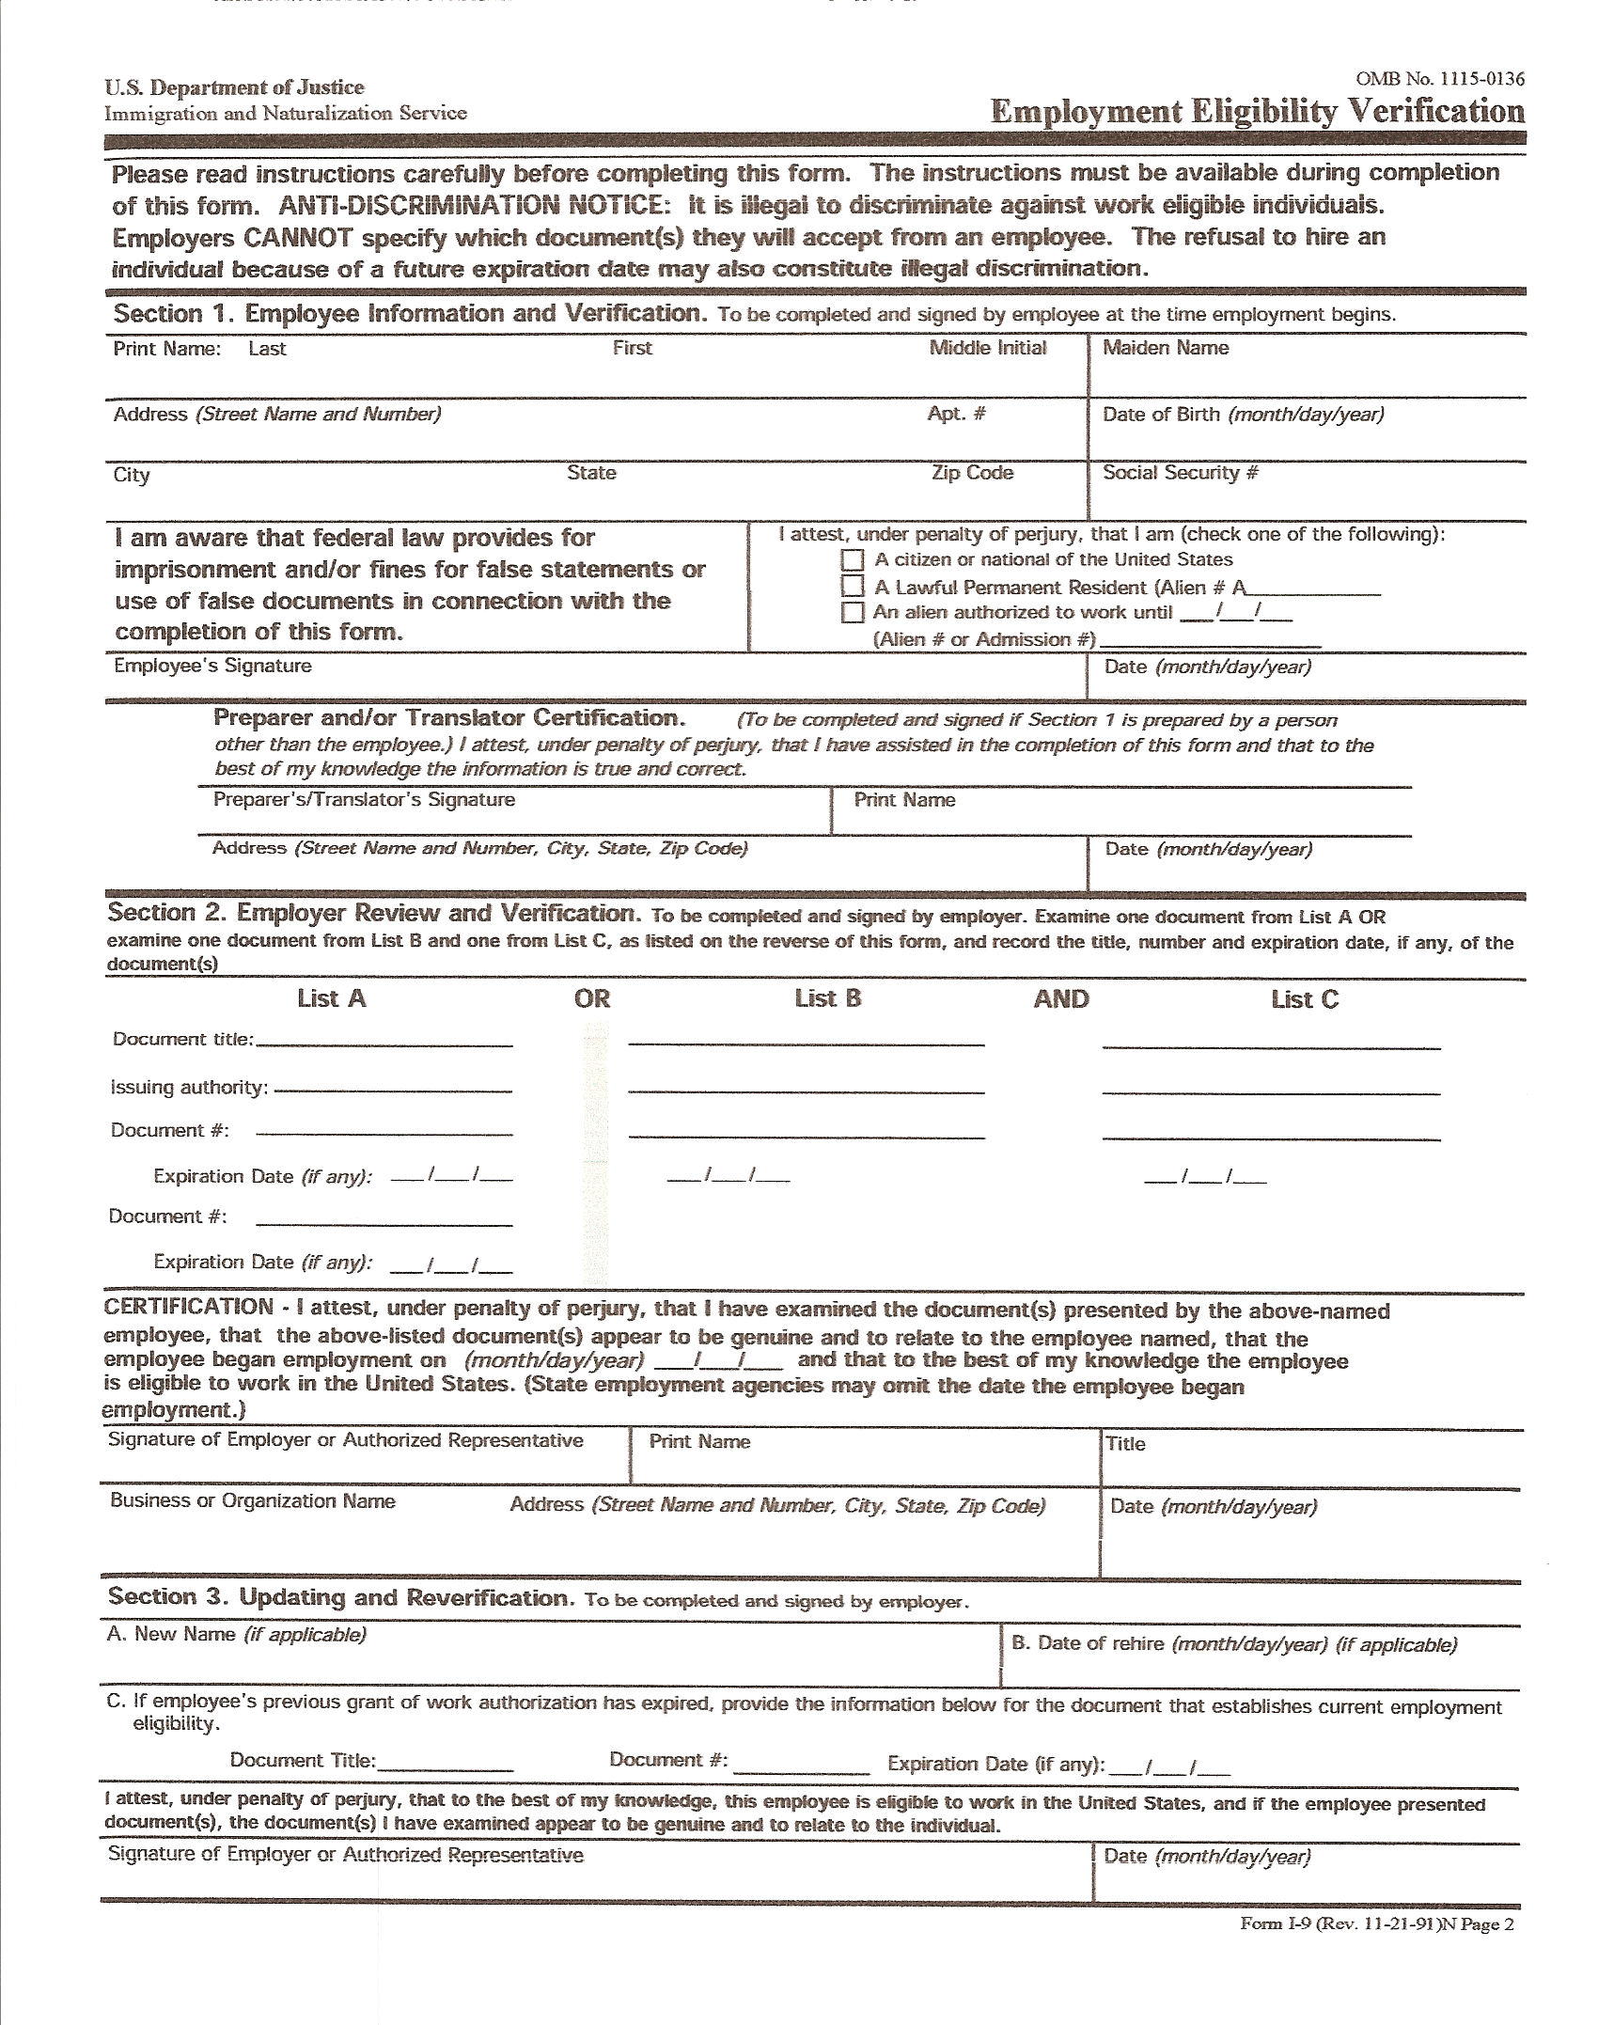

Driver’s License
Social Security Card
Dr. Nikki Keefer Director

Collaborative Solutions
3516 Wild Eagle Run Oviedo FL 32766
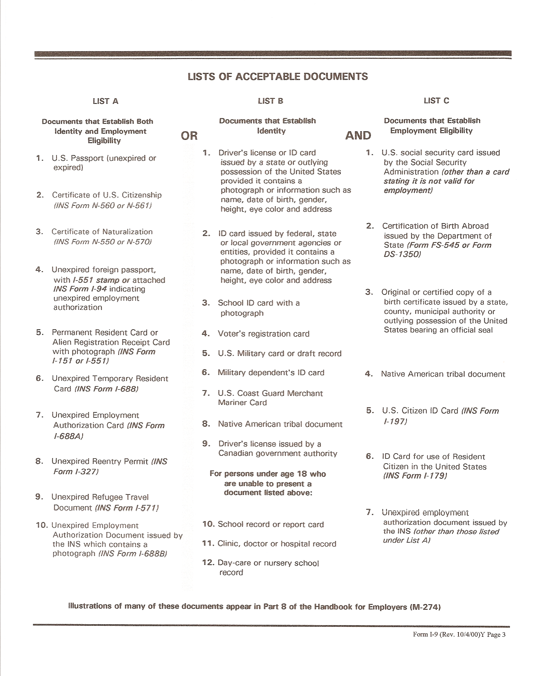


AFFIDAVIT OF GOOD MORAL CHARACTER

State of Florida

County of ______________

Before me this day personally appeared ___________________________ who being duly sworn, deposes and says:

I am an applicant for employment as a caretaker with:

Collaborative Solutions By Dr. Nikki Keefer & Assoc., Inc.
-----------------------------------------------------------------------------------------------------------------------------

By signing this form, I am swearing that I have not been found guilty or entered a plea of nolo contendere (no contest), regardless of the adjudication, to any of the following charges under the provisions of the Florida Statutes or under any similar statute of another jurisdiction. I also attest that I do not have a delinquency record that is similar to any of these offenses.

I understand I must acknowledge the existence of any criminal records relating to the following list regardless of whether or not those records have been sealed or expunged. I understand that I am also obligated to notify my employer of any possible disqualifying offenses that may occur while employed in a position subject to background screening under Chapter 435, Florida Statutes.

Relating to:
Sections: 415.111 adult abuse, neglect, or exploitation of aged persons or disabled adults
741.30 domestic violence and injunction for protection
782.04 murder
782.07 manslaughter, aggravated manslaughter of an elderly person or disabled adult, or aggravated manslaughter of a child
782.071 vehicular homicide
782.09 killing an unborn child by injury to the mother
784.011 assault, if the victim of the offense was a minor
784.021 aggravated assault
784.03 battery, if the victim of the offense was a minor
784.045 aggravated battery
784.075 battery on a detention or commitment facility staff
787.01 kidnapping
787.02 false imprisonment
787.04(2) taking, enticing or removing a child beyond the state limits with criminal intent, pending custody proceedings
787.04(3) carrying a child beyond the state lines with criminal intent to avoid producing a child at a custody hearing or delivering the child to the designated person
790.115(0) exhibiting firearms or weapons within 1,000 feet of a school
790.115(2)(b) possessing an electric weapon or device, destructive device, or other weapon on school property
794.011 sexual battery
794.041 (former section 794.041) prohibited acts of persons in familial or custodial authority
Chapter: 796 prostitution
Section: 798.02 lewd and lascivious behavior
Chapter: 800 lewdness and indecent exposure
Section: 806.01 arson
Chapter: 812 felony theft and/or robbery
Sections: 817.563 fraudulent sale of controlled substances, if the offense was a felony
825.102 abuse, aggravated abuse, or neglect of disabled adults or elderly persons
825.1025 lewd or lascivious offenses committed, upon or in the presence of an elderly person or disabled adult
825.103 exploitation of disabled adults or elderly persons, if the offense was a felony
826.04 incest
827.03 child abuse, aggravated child abuse or neglect of a child
827.04 contributing to the delinquency or dependency of a child
827.05 negligent treatment of children
827.071 sexual performance by a child
843.01 resisting arrest with violence
843.025 depriving an officer means of protection or communication

--- CONTINUED ON BACK ---
843.12 aiding in an escape
843.13 aiding in the escape of juvenile inmates in correctional institution
Chapter: 847 obscene literature
Sections: 874.05(1) encouraging or recruiting another to join a criminal gang
Chapter: 893 drug abuse prevention and control only if the offense was a felony or if any other person involved in the offense was a minor
Sections: 944.35(3) inflicting cruel or inhuman treatment on an inmate resulting in great bodily harm
  - harboring, concealing, or aiding an escaped prisoner
  - introduction of contraband into a correctional facility
  - sexual misconduct in juvenile justice programs
  - contraband introduced into detention facilities
ONE OF THE FOLLOWING STATEMENTS MUST BE MADE:

Under the penalty of perjury, which is a first degree misdemeanor, punishable by a definite term of imprisonment, not exceeding one year and/or a fine not exceeding $1000 pursuant to ss.837.012, or 775.082, or 775.083, Florida Statutes, I attest that I have read the foregoing, and I am eligible to meet the standards of good character for this caretaker position.

___________________________________________________
Signature of Affiant

OR

To the best of my knowledge and belief, my record may contain one or more of the foregoing disqualifying acts or offenses.

__________________________________________________
Signature of Affiant

OR
for teachers and non-instructional personnel in lieu of fingerprint submission:

I swear that I have been fingerprinted under Chapter 231, Florida Statutes, when employed as a teacher or non-instructional employee and have not been unemployed from the school board for more than 90 days. I swear the findings of that background check did not include any of the above offenses and that I meet the standards of good character for this caretaker position.

_________________________________________________
Signature of Affiant

OR

To the best of my knowledge and belief, my record may contain one or more of the foregoing disqualifying acts or offenses.

__________________________________________________
Signature of Affiant

Sworn to and subscribed before me this _____ day of __________________ , 20____.

___________________ _____________________________________
My commission expires NOTARY PUBLIC, STATE OF FLORIDA

My signature, as a Notary Public, verifies the affiant’s identification has been validated by:

________________________________________________________________
Adaptation of CF 1649, Feb 97 (Obsoletes previous editions and HRS Form 1732)
Local Law Enforcement Check

Instructions to Applicant: At least one week prior to your start date, fax this completed/signed form to the Sheriff’s department for the county you live in and Seminole and Orange counties. Submit this form and the fax confirmation with the new-hire packet. You may also go to the Sheriff’s department in person to have this form completed.
Orange County Sheriff, Records Department: phone (407) 254-7280
Seminole County Sheriff, Records Department: fax (407) 665-6655, phone (407) 665-6650
Osceola County Sheriff, Records Department: fax (407) 348-3395, phone (407) 348-1157

Pursuant to Chapter 85-54, Laws of Florida, we request a local records check on the applicant listed below:

_____________________________ _____________________________ _____________
Last Name First Name Middle Name

_____________________ ___________ _________ ___________________________
Date of Birth Race Sex Social Security Number

Please document the findings and return the information to:

Collaborative Solutions By Dr. Nikki Keefer & Assoc. Inc.
3526 Wild Eagle Run
Oviedo, FL 32766
FAX: (407) 542-4806
Phone: (407) 489-2121

I hereby authorize the local law enforcement agency to check any and all records pertaining to criminal convictions and to release to the above-named agency any information regarding convictions under Florida Statute or statutes of other jurisdictions.

_____________________________________________________ _______________________

Applicant’s Signature Date
LAW ENFORCEMENT FINDINGS:

Contract - PRIMARY CLINICIAN

Agreement made with intent to be legally bound, between Collaborative Solutions, Inc. (“Agency”) and the following named contractor (“Contractor”):

Agency: Contractor:

Collaborative Solutions Name: ________________________________________
3516 Wild Eagle Run Address: ______________________________________
Oviedo, Florida 32766 City/State/Zip: ________________________________
(407) 489-2121 Cell Phone:____________________________________
nixabcba@aol.com e-mail address: _______________________________
Contact Person: Dr. Nikki Keefer Social Security #: ______________________________

Contractor Specialty: Behavior Analysis

TERMS:
- The Contractor will contact the client within 2 days after being assigned a case to schedule an intake session. The Contractor will also contact the Licensed Evaluator (Medicaid cases only), when required, and attempt to have the LE attend the intake session.
- Within 2 days after the intake session, the Contractor will contact the referral source to notify him/her that the case has been opened.
- The Contractor will adhere to documentation and service requirements for each client’s specific funding source, as specified in the Collaborative Solutions Procedure Manual or as amended in memos.
- The Contractor will turn in case documentation for ongoing services every Monday by 12:00 pm, or as amended in a policy change memorandum. Payment will be issued every 2 weeks for those services which have documentation that comply with requirements.
- The Contractor will maintain a minimum of weekly face-to-face contact with all active clients, except when fading services. Reasons for missed sessions and weeks without contact will be documented in notes.
- The Contractor will apprise the Clinical Supervisor of case status and progress on a biweekly basis.
- The Contractor will prescribe behavioral strategies that adhere to least restrictive, least intrusive, most effective criteria.
- The Contractor will, with the cooperation of the client and caregiver, formally review Individualized Treatment Plans for each client every three months, in keeping with generally accepted clinical practice. These reviews will be documented and signed by the client and guardian.
- The Contractor will obtain approval from the Program Director prior to extending services beyond 6 months, and again if requesting that services extend beyond the original extension period. After Director approval, the Contractor will complete the documentation required to extend the case, as specified in the Collaborative Solutions Procedure Manual.
- The Contractor will complete discharge paperwork, as specified in the Collaborative Solutions Procedure Manual, within 15 days of the last documented activity on the case.
- The Contractor agrees that Collaborative Solutions is the custodian of all client records. The Contractor agrees to submit all records and documents (including electronic storage media) related to clients of Collaborative Solutions.
- Upon discharge of a client, the Contractor will turn all copies and original documents related to the case into the office.
- The Contractor will contact the referral source within 15 days after case termination to notify him/her of this event.
- The Contractor will maintain the confidentiality of client information, both spoken and written, unless written release of information to a specific individual or agency is obtained from the client’s legal guardian. Exceptions include releasing information to the abuse registry when the Contractor suspects abuse or neglect, to the abuse investigator during an abuse investigation, to warn a potential victim if the Contractor believes someone’s life is in danger, or to the court when subpoenaed.
- The Contractor will follow state mandated abuse & neglect reporting procedures regarding abuse/neglect of children, disabled individuals, or elderly individuals.
- During crisis situations, the Contractor will use verbal de-escalation techniques and avoid physically restraining clients. In the event that the client’s safety is at risk, the Contractor will call 911. If there is imminent danger to the client or Contractor prior to police response, the Contractor will use the least restrictive intervention possible to maintain safety. In the event that emergency physical intervention is used, the Contractor will contact the Program Director within 24 hours and submit an Incident Report within 2 days.
- The Contractor agrees to maintain a current Florida Drivers License but will not transport clients.
- The Contractor agrees to maintain a confidential voice mail phone number that he/she will check on a regular basis. As consistent with standards of clinical practice, the Contractor will not give his/her home phone or other non-confidential phone number (e.g., phone number at a second job) to clients.
- The Contractor agrees that he/she may not subcontract any services without prior written permission from Collaborative Solutions.
- The Contractor agrees to abide by all the procedures and policies in the Collaborative Solutions Procedure manual, received at Orientation.
- The Contractor agrees to report to the program director or compliance officer of any suspicion of fraudulent billing, false documentation or other quality assurance and compliance concerns.
- The Contractor agrees to report any arrests, convictions or legal involvement which may disqualify him/her from providing services to children in the state of Florida.
- The Contractor is responsible for paying all taxes, as taxes are not withheld for payment to Contractors. Collaborative Solutions will provide the Contractor with a 1099 form at the end of the year as required by law.
- Collaborative Solutions does not cover the Contractor for worker’s compensation or unemployment benefits. The Contractor is responsible for all business-related expenses.
- The Contractor will pass a full background screening, as required by Department of Children & Families.
- The Contractor will follow acceptable standards of professional conduct.

The Contractor agrees to the general terms and conditions of this agreement, which are incorporated herein, acknowledges that he/she has read and understood the terms, and certifies that the information provided to Collaborative Solutions is true and correct. This contract may be terminated by either party with a minimum of 30 days notice.

CONTRACT PERIOD:

FROM: _____________________ TO: ____________ .
PAYMENT FOR SERVICES: Collaborative Solutions will issue payment for services that comply with the terms of this contract every 4 weeks. Pay is $__________________

_________________________________________ ________________________________________
Contractor Signature Dr. Nikki Keefer, Collaborative Solutions

Confidentiality/HIPAA Agreement
Staff Name:____________________________________________________________

The Health Insurance Portability and Accountability Act of 1996 (HIPAA) is federal legislation covering three areas: insurance portability, ensuring that individuals moving from one health plan to another will have continuity of coverage, fraud enforcement, which expanded the federal government’s authority to punish those who violate the client confidentiality and privacy, and administrative simplification, which is designed to reduce healthcare costs. With the enactment of HIPAA, a client's right to have health information kept private became more than just an ethical obligation--it became the law. Punishment for HIPAA violations can result in large fines and possible jail time.

Client Privacy. There are some basic rules to ensure client privacy:
- Client care and discussions regarding client care are kept private by closing room doors and conducting discussions so that others may not overhear them.
- Client financial information is discussed in a private area, and is used only to determine eligibility for benefits.
- Confidential information is not left on an answering machine that is accessible to someone other than the client.
- Client records and any other written client information are not left where others can see or access them.
- Client records are kept in a locked location, and only people with a need to see information about clients should have access to them.
- Shred documents containing client information, when needing to purge; do not leave them in the garbage.
- Computer screens containing client information must be turned away from the view of people passing by and staff must log off computers with access to client information when leaving the workstation.
- Electronic records are kept secure, and access to these records is given only to those with a need to know for the purpose of client care.
- Use encryption and passwords to protect electronic client information that is stored or sent on public networks

Individually Identifiable Information, which is any information that might identify someone, is protected under the privacy section HIPAA. Elements that make information identifiable include the following: Name, Address, Employer, Relatives' names, Date of birth, Telephone and fax number, E-mail address, Social Security number, Member or account number, Certificate numbers, Voiceprints, Fingerprints, Photos, Codes, any other characteristics, such as occupation, which may identify the individual.

Minimum Necessary Information. HIPAA’s privacy rule allows healthcare staff to use or share only the "minimum necessary" information in order to perform their function. Healthcare professionals use information about clients to determine treatment needs. Billing staff use confidential information to bill clients or their insurance companies for the services they receive. Administrative staff review confidential information to make sure that clients receive good care. Before sharing or seeking information, ask yourself “Is this information needed to perform this job?” and “What is the least amount of information needed to do this job?” Providers can disclose information requested by other healthcare providers only if the information is necessary for treatment.

Authorization to Release Information. In order to disclose confidential client information to anyone other than the client, HIPAA requires written authorization, in which the client voluntarily gives permission only for a particular request or need. Clients have the right to revoke their authorization at any time. Providers cannot deny treatment to clients who refuse to sign authorization forms. Psychotherapy notes have much stronger protections, requiring individual authorization, not just a general consent for release of records.

Exceptions to Privacy. Under certain conditions, information about clients may be released without the written authorization of the client. These include
- Reporting communicable diseases that are required to be reported to state health agencies.
- Reporting certain medical devices that break or malfunction that are required to be reported by the Food and Drug Administration (FDA).
- Reporting suspected child abuse or neglect (or the abuse of developmentally disabled or elderly individuals) to the state protection agency (1-800-96 ABUSE)
- Warning potential victims of homicidal intent.
- When ordered by the court to release client records or give testimony in court.

I understand the information regarding HIPAA requirements for the protection of client privacy and confidentiality and agree to follow these rules.

______________________________________________________ _________________________
Staff Signature Date
Child Abuse & Neglect
Reporting Requirements Acknowledgment

Staff Name: _______________________________________________

All child care personnel are mandated by law to report their suspicions of child abuse, neglect, or abandonment to the Florida Abuse Hotline in accordance with section 415.504(1)(e) of the Florida Statutes (F.S.).

“Child Abuse or Neglect” is defined in s. 415.503(3). F.S., as “harm or threatened harm” to a child’s mental or physical health or welfare by the acts or omissions of a parent, adult household member, or other person responsible for the child’s welfare, or for purpose of reporting requirements by any person.
- Reports must be made immediately to the centralized Florida Abuse Hotline at
1-800-96 ABUSE (962-2873).

- All reports are confidential. However, persons who are mandated reporters (child care personnel) are required to give their name when making a report.

- It is important to give as much identifying and factual information as possible when making a report.

- Any person, when acting in good faith, is immune from liability in accordance with s. 415.511, F.S.

- Child care personnel must be alert to the physical and behavioral indicators of child abuse and neglect.

Categories Include: Physical Abuse (i.e. unexplained bruise, burns)
Physical Neglect (i.e. hunger, poor hygiene, lack of supervision)
Sexual Abuse (i.e. withdrawal, excessive crying, physical symptoms)

I certify that I read the above material. I further understand that I am required by law to report suspected child abuse and neglect in accordance with the mandates of s. 415.502. F.S.

____________________________________________________ ____________________________
Staff Signature Date
Clearance Request

Applicant Name: ____________________________________________

If you are currently employed, or were employed within the past 90 days, at an agency that required a Level II clearance (e.g., school, mental health agency, daycare, developmental disability agency), you may substitute a copy of the FDLE clearance and DCF clearance letter (federal clearance) from that employer in lieu of a new fingerprint card.

Please attach copies of your current FDLE and federal clearance documents to your new hire packet. If unable to do so, please complete the information below and we will make the request on your behalf.

Current Employer (within past 90 days):

Agency Name: ___________________________________________________
Human Resources Contact: _____________________________________________________________
Phone #: ____________________________ Email: ___________________________________________

I authorize the above employer to release a copy of my clearance letter and FDLE check to Collaborative Solutions
3516 Wild Eagle Run
Oviedo, FL 32766-8131
(407) 489-2121
(407) 542-4806 (fax)

Signature: _______________________________________________ Date: _______________________

*************************Level 2 Background Screening (FBI and FDLE) *************************

The Clearinghouse Results Website is used to initiate screenings, search approved LiveScan vendors, check/print screening results, and maintain an employee roster. In order for us to initiate a background screening for your employment through the clearinghouse you must first fill out and sign our Background Screening Release and the ACHA Background Screening Privacy Practices.

Once you have been entered into the background clearinghouse you will receive a LiveScan Request Form and fingerprinting appointment locations. You will then need to make an appointment or go to a location that accepts walk-ins. Some locations require that fingerprinting be paid for at the time you book the appointment. Fingerprinting charges and fees vary by location but average $100. You must take the LiveScan Request Form along with your valid photo ID to your fingerprinting appointment. Fingerprint results may take anywhere from 72hours up to 5 weeks to be processed and sent to us. Once they are available we will electronically receive your results.

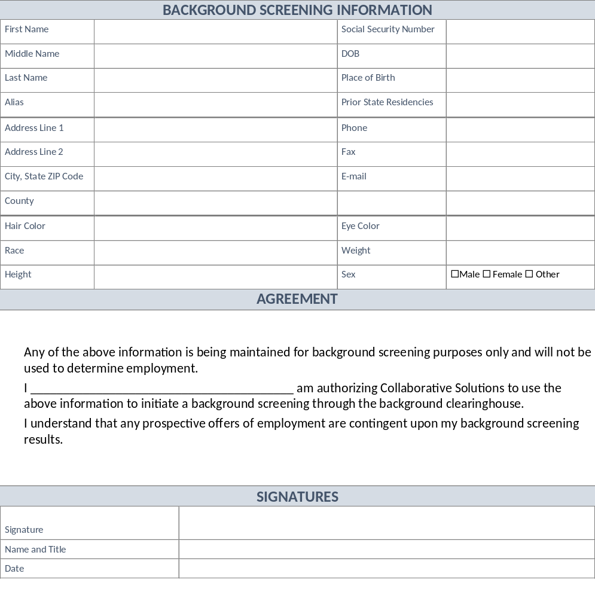

Additional Trainings

Additional training is required for based upon APD regulations and the different insurance company’s requirements. These trainings include (but are not limited to)

- HIPAA Basics
- Direct Care Core Competencies
- Zero Tolerance
- HIV/Communicable Diseases
- CPR/First Aid
- Incident Reporting
- Ethics Training
- Reactive Strategies

These requirements are constantly changing and are posted on the APD website. All courses must be certified through an official APD vender.

http://apdcares.org/providers/training/required-basic-training.htm

